Software Requirement Engineering Group Project
Lab 1: Introduction to Requirements Engineering Tools
Step 1: Install and set up the required software tools on your computer:
Microsoft Word

Draw.Io
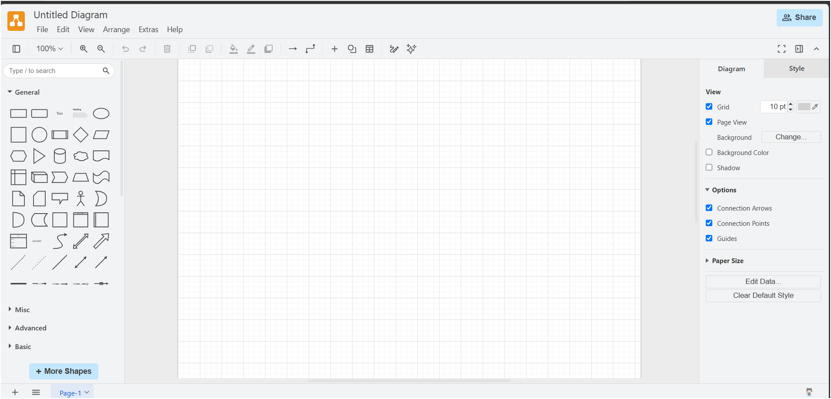
StarUML
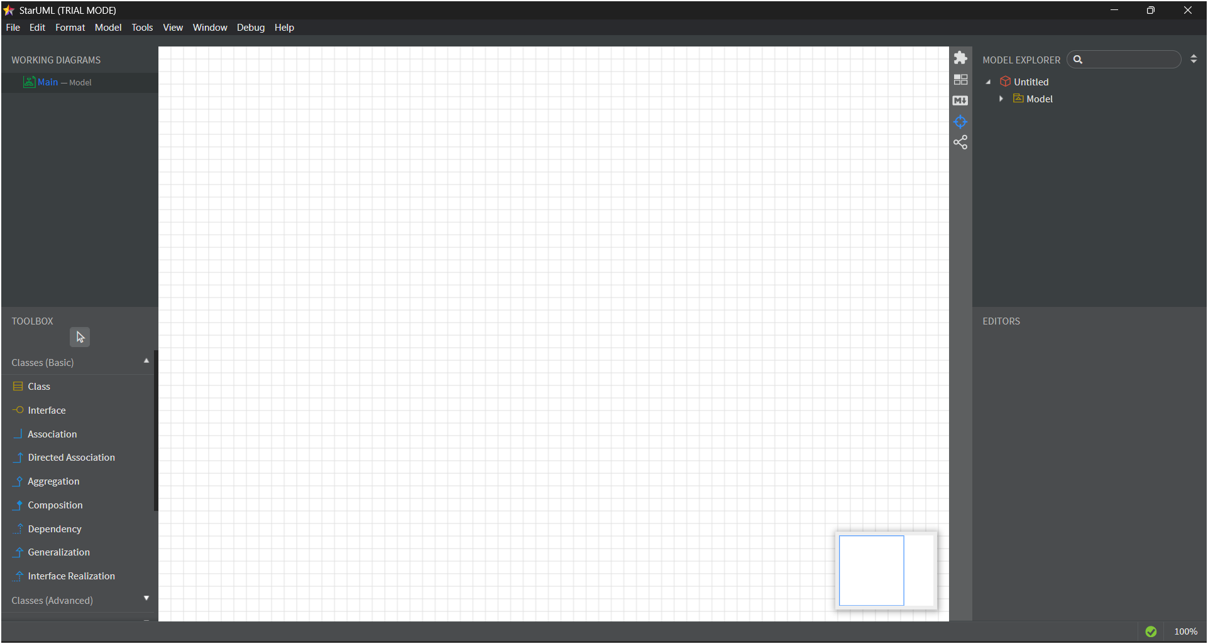
GitH ub
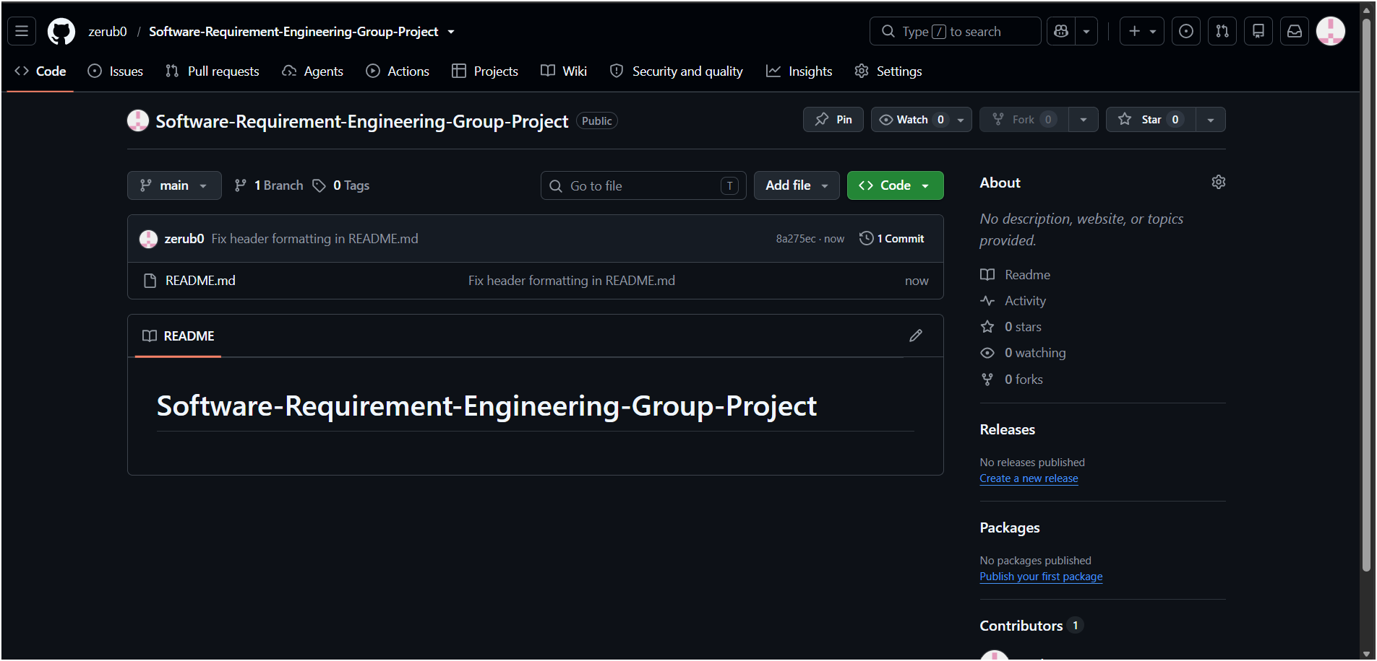
Step 2: Create a project workspace/folder structure on your computer. Organize it with subfolders:
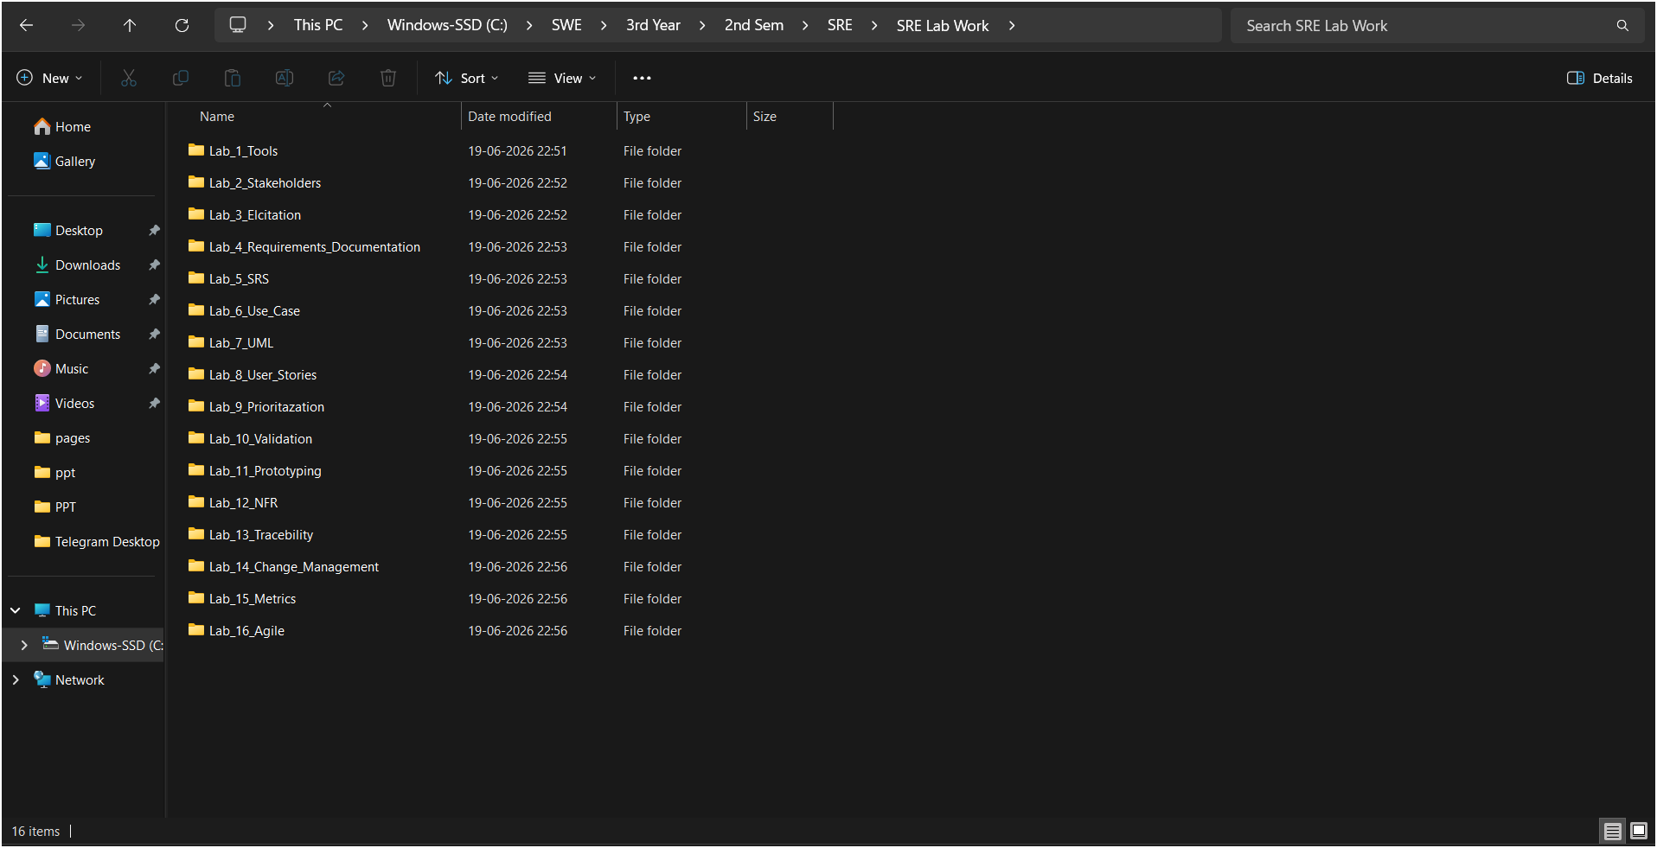
Step 3: Open Draw.io and create a simple diagram to practice using the diagramming functions.
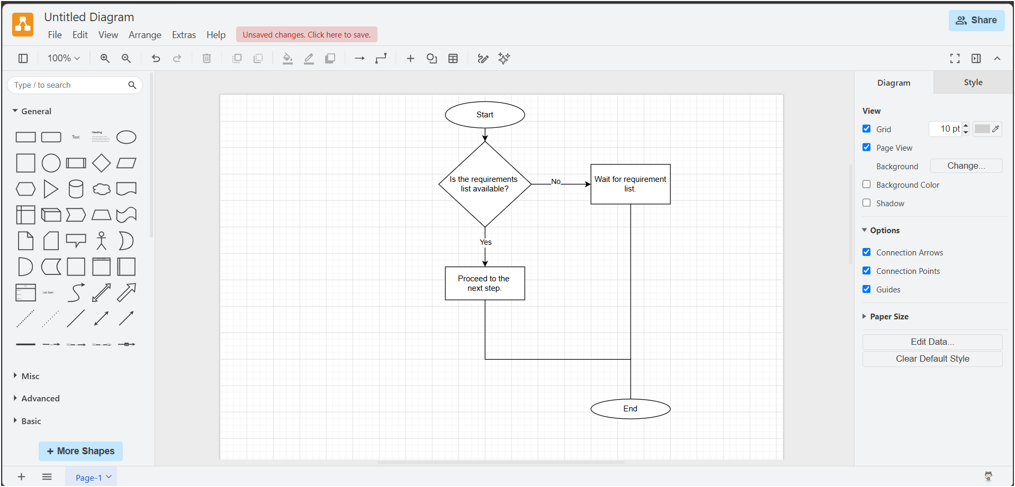
Step 4: Prepare a Sample Requirement Statement Document
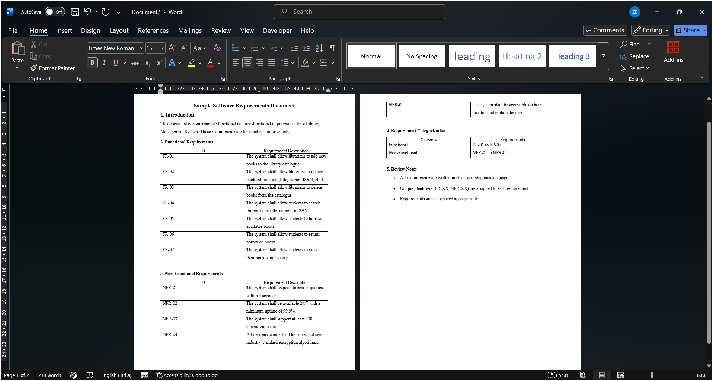
Step 5: GitHub Repository Link
zerub0/Software-Requirement-Engineering-Group-Project

